Kingsley Oti Amponsah
Enhancement two: Algorithms and Data structures
Artifact used: Image Augmentation
2/8/2026
Justification and purpose
This artifact is a key factor in showcasing my skill and knowledge in the area of image augmentation. It also demonstrates my abilities on how to use CNN model on CIFAR-10 datasets to improve the resolution of an image without the traditional way of rotating, zooming etc.
Brief on CNN model on CIFAR-10
With the use of picture augmentation, a straightforward CNN will be able to achieve an accuracy of 90.3% on CIFAR_10. Within the realm of machine learning and computer vision, the CIFAR-10 dataset is a collection of photographs that are frequently utilized for the purpose of training algorithms. According to studies on machine learning, it is one of the datasets that is utilized the most frequently. For starters, 60,000 32x32 color pictures are included in the CIFAR-10 dataset, which is organized into ten distinct categories. Airplanes, automobiles, birds, cats, deer, dogs, frogs, horses, and trucks are the ten distinct classes that correspond to the many types of vehicles. Every category has a total of 6,000 pictures.
CNNs, which stand for convolutional neural networks, have emerged as a fundamental component in the field of computer vision. They have made it possible for machines to attain exceptional accuracy in image identification tasks. This milestone project explores the use of convolutional neural networks (CNNs) on the CIFAR-10 dataset, which is a benchmark that is extensively used in the world of machine learning. I will investigate the complete process, beginning with the comprehension of the dataset and continuing through the construction, training, and evaluation of the CNN model.
Approach
In order to avoid overfitting the model, machine learning functions most effectively when there is a large amount of training data, which in this case consists of photographs. If there is a shortage of training data, it is possible to artificially increase it through the use of picture augmentation. As a result of performing operations such as rotating, shifting, zooming, and other operations on the initial training picture, new images are generated here. My own experience has shown that I am able to get a classification accuracy of more than 90 percent on the CIFAR_10 dataset, which has 50,000 training pictures divided into ten categories: airplane, car, bird, cat, deer, dog, frog, horse, ship, and truck. I tried a variety of operations, and it seems that rotations, horizontal flips, and shifts in either the vertical or horizontal direction were the most effective. A VGG-type convolutional network is used for the model, and it consists of six convolutional layers and one dense fully connected layer that comes before the output. Image enhancement is not the only technique that is utilized; batch normalization (in each layer) and dropout in the dense layer are also utilized.
Getting started
Installing the required libraries into our Python environment is the first step in getting started with this project. TensorFlow and Keras are going to be utilized in the process of constructing and training our CNN model. This can be done by using the below code to import various libraries, datasets, layers, models etcfrom TensorFlow and Keras:
import tensorflow as tf
from tensorflow.keras import datasets, layers, models
import matplotlib.pyplot as plt

we then go ahead and load the data by using the code syntax below:

(x_train, y_train), (x_test, y_test) = cifar10.load_data()
img_rows, img_cols , channels= 32,32,3
for i in range(0,9):
plt.subplot(330 + 1 + i)
plt.imshow(x_train[i])
plt.show()
The subsequent procedure is demonstrated in the attached ipynb file.
Results
The initial image accuracy without the augmentation process stood at 82.8%.
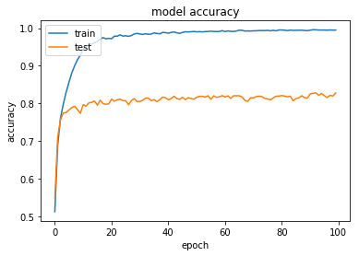
With the Image augmentation been used and still rising after 100 epochs, the accuracy stood at 90.3% test accuracy.

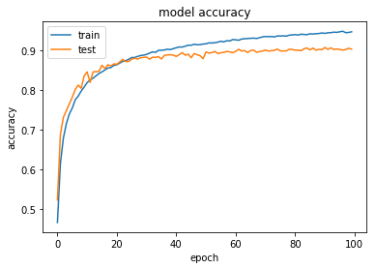
What I have learned
Working on this project has provided me with the opportunity to acquire fundamental knowledge in computer vision. This includes the development of deep learning models for multi-class image classification, which consists of ten classes; the implementation of convolutional and pooling layers for feature extraction; the prevention of overfitting through dropout and augmentation; and the utilization of frameworks such as PyTorch or TensorFlow to achieve high classification accuracy. In addition, this research acts as a common benchmark for learning how to categorize color pictures, making the shift from shallow networks to deep, high-performance structures.

